Introduction to Java:
Java is a high-level, object-oriented programming language created in 1995. It is platform-independent, secure, and widely used for mobile, web, desktop, and enterprise applications.
Key features of Java :
Java is object-oriented, platform-independent, secure, and supports multithreading. It provides rich APIs, strong memory management, and scalability for building diverse applications.
Uses of Java :
Java is widely used for mobile app development (Android), web applications (Spring, Hibernate), desktop GUI (JavaFX, Swing), enterprise systems (banking, ERP), game development (Minecraft, LibGDX), big data (Hadoop, Kafka), IoT devices, cloud services (AWS, Azure, GCP), and scientific applications.
How to Download Java:
1. Go to Oracle Java Downloads (oracle.com in Bing).
2. Select Windows → choose the installer → download.
3. Run the installer and finish setup.
4. Set environment variables:
JAVA_HOME → JDK folder
Add %JAVA_HOME%\bin to PATH
- Verify with java -version in CMD.
Single-line comment:
// This is a comment

Multi-line comment:
/*
This is a multi-line comment.
This is useful for explaining larger sections of code.
*/
Code 1
public class HelloWorld {
public static void main(String[] args) {
System.out.println("Hello World!");
}
}
Output
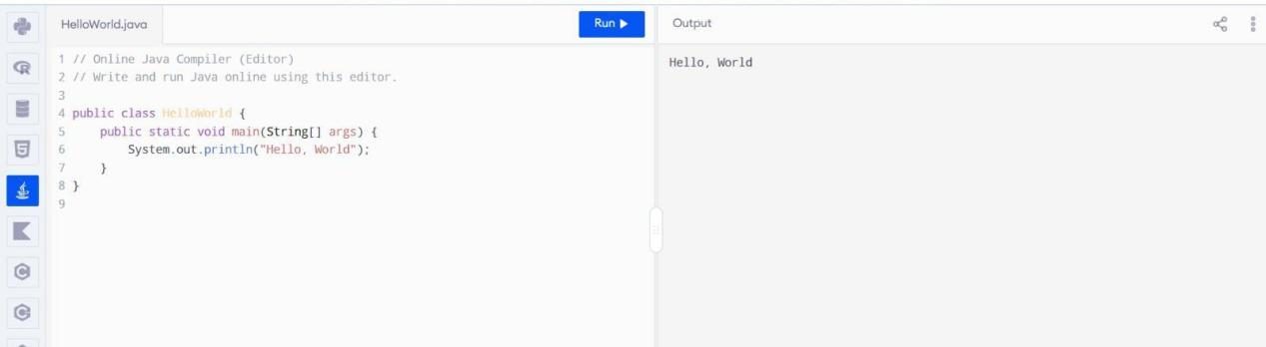

Code 2
public class Daffodil {
public static void main(String[] args) {
{
System.out.println("This is inside the block.");
}
System.out.println("This is outside the block.");
}
}

Output
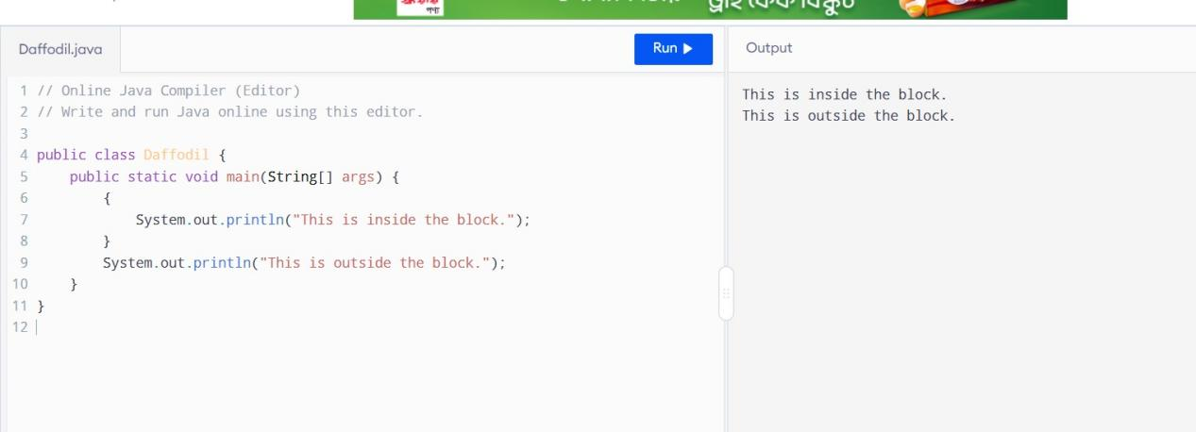

Github :

